**#Item frequency plot**

* itemFrequencyPlot(Trans, topN = 10,type = "relative", xlab = "Top 10 Products", ylab = "Percentage of all Transactions")

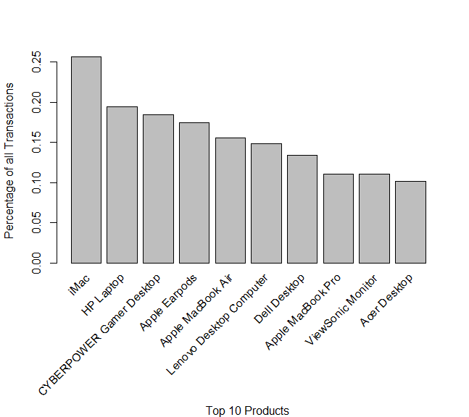

**# image does not provide much insight as the items are defined by number and does not show the distribution (itemfreqplot is more helpful)**

* image(sample(Trans,30)) # plot 30 trans (dataset,number of rows)

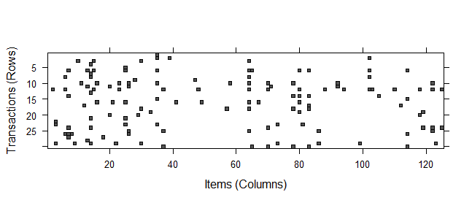

**#returned 18 rules**

* ap_18 <- apriori(Trans, parameter = list(supp = 0.04, conf = .20, maxtime = 60, minlen = 2, maxlen = 30, target = "rules"))

|  |  |  |  |  |  |  |
| --- | --- | --- | --- | --- | --- | --- |
| **Rule** | **People who buy …** | **Uusually buy this** | **Support** | **Confidence** | **Lift** | **Count** |
| 1 | ViewSonic Monitor | HP Laptop | 5% | 44% | 2.24 | 472 |
| 2 | HP Laptop | ViewSonic Monitor | 5% | 25% | 2.24 | 472 |
| 3 | ViewSonic Monitor | iMac | 5% | 45% | 1.75 | 486 |
| 4 | Dell Desktop | HP Laptop | 4% | 34% | 1.73 | 442 |
| 5 | HP Laptop | Dell Desktop | 4% | 23% | 1.73 | 442 |
| 6 | Lenovo Desktop Computer | HP Laptop | 5% | 31% | 1.61 | 454 |
| 7 | HP Laptop | Lenovo Desktop Computer | 5% | 24% | 1.61 | 454 |
| 8 | iMac | Dell Desktop | 5% | 21% | 1.59 | 537 |
| 9 | Dell Desktop | iMac | 5% | 41% | 1.59 | 537 |
| 10 | Lenovo Desktop Computer | iMac | 6% | 40% | 1.55 | 578 |
| 11 | iMac | HP Laptop | 6% | 23% | 1.55 | 578 |
| 12 | HP Laptop | iMac | 8% | 39% | 1.52 | 743 |
| 13 | iMac | HP Laptop | 8% | 29% | 1.52 | 743 |
| 14 | CYBERPOWER Gamer Desktop | iMac | 6% | 31% | 1.20 | 558 |
| 15 | iMac | CYBERPOWER Gamer Desktop | 6% | 22% | 1.20 | 558 |
| 16 | CYBERPOWER Gamer Desktop | HP Laptop | 4% | 23% | 1.19 | 419 |
| 17 | HP Laptop | CYBERPOWER Gamer Desktop | 4% | 22% | 1.19 | 419 |
| 18 | Apple Earpods | iMac | 4% | 23% | 0.90 | 396 |

**#matrix favorite visual**

* m_trax <- plot(ap_18, method="matrix", control=list(verbose = TRUE))

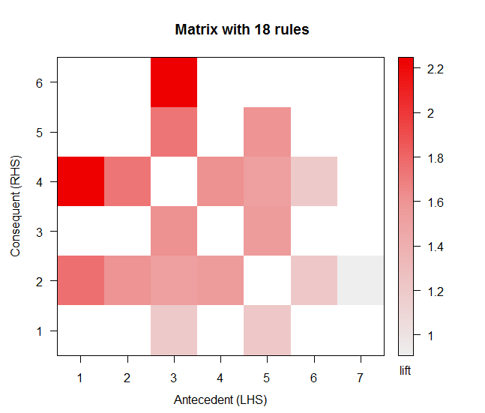

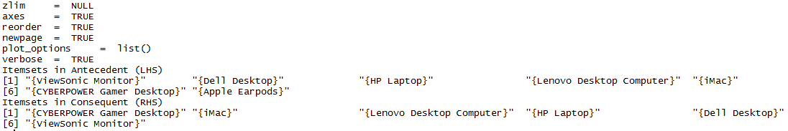

**#graph**

* graph <- plot(ap_18, measure=c("support","lift"), shading="confidence")

**#interactive graph**

* i_graph <- plot(ap_18, measure=c("support","lift"), shading="confidence", interactive = TRUE)

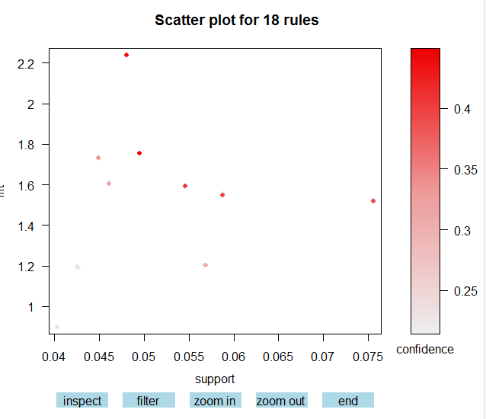

**#two tone graph**

* t_graph <- plot(ap_18, shading="order", control=list(main ="Two-key plot"))

